Scottish Highlands

Research document

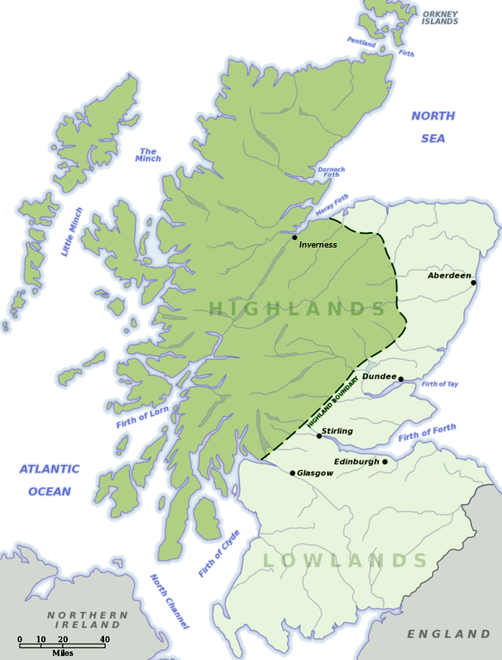

# **Caledonian Forest**

The ecoregion of the Highlands is called the Caledonian Forest. Being a unique ecosystem in the British Isles, the Caledonian Pinewoods are home to some of the country's rarest wildlife. It is considered to be one of the last remaining wildernesses in the British Isles.

List of species found in the region:

* [Western capercaillie](https://en.wikipedia.org/wiki/Western_capercaillie)
* [Common goldeneye](https://en.wikipedia.org/wiki/Common_goldeneye)
* [European crested tit](https://en.wikipedia.org/wiki/European_crested_tit)
* [Parrot crossbill](https://en.wikipedia.org/wiki/Parrot_crossbill)
* [Scottish crossbill](https://en.wikipedia.org/wiki/Scottish_crossbill)

Breeding bird species in Caledonian pine forests **rare** elsewhere in the British Isles:

* [Black grouse](https://en.wikipedia.org/wiki/Black_grouse)
* [Red crossbill](https://en.wikipedia.org/wiki/Red_crossbill)
* [Goosander](https://en.wikipedia.org/wiki/Common_merganser)
* [Siskin](https://en.wikipedia.org/wiki/Eurasian_siskin)
* [Redpoll](https://en.wikipedia.org/wiki/Lesser_redpoll)
* [Long-eared owl](https://en.wikipedia.org/wiki/Long-eared_owl)
* [Osprey](https://en.wikipedia.org/wiki/Osprey)
* [Red-breasted merganser](https://en.wikipedia.org/wiki/Red-breasted_merganser)
* [Redwing](https://en.wikipedia.org/wiki/Redwing)
* [Temminck's stint](https://en.wikipedia.org/wiki/Temminck%27s_stint)
* [Wood sandpiper](https://en.wikipedia.org/wiki/Wood_sandpiper)
* [Horned grebe](https://en.wikipedia.org/wiki/Horned_grebe)
* [Golden eagle](https://en.wikipedia.org/wiki/Golden_eagle)
* [Eurasian beaver](https://en.wikipedia.org/wiki/Eurasian_beaver)[[3]](https://en.wikipedia.org/wiki/Caledonian_Forest#cite_note-3)
* [Feral goat](https://en.wikipedia.org/wiki/Feral_goat)
* [Mountain hare](https://en.wikipedia.org/wiki/Mountain_hare)
* [European pine marten](https://en.wikipedia.org/wiki/European_pine_marten)
* [Red deer](https://en.wikipedia.org/wiki/Red_deer)
* [Red fox](https://en.wikipedia.org/wiki/Red_fox)
* [Red squirrel](https://en.wikipedia.org/wiki/Red_squirrel)
* [Roe deer](https://en.wikipedia.org/wiki/Roe_deer)
* [Wildcat](https://en.wikipedia.org/wiki/Wildcat)

Mammal species **extinct** in Caledonian pine forests:

* [Aurochs](https://en.wikipedia.org/wiki/Aurochs)
* [Brown bear](https://en.wikipedia.org/wiki/Brown_bear)
* [Eurasian lynx](https://en.wikipedia.org/wiki/Eurasian_lynx)
* [Gray wolf](https://en.wikipedia.org/wiki/Gray_wolf)
* [Moose](https://en.wikipedia.org/wiki/Moose) (called "Elk" in British English)
* [Tarpan](https://en.wikipedia.org/wiki/Tarpan) ([wild horse](https://en.wikipedia.org/wiki/Wild_horse))
* [Wild boar](https://en.wikipedia.org/wiki/Wild_boar)

**Note:** I found the fact that almost everything interesting there is extinct problematc. How is Mollie supposed to transform into an animal, if she has to meet said animal…unless…time travel is a thing? This needs to be a subject of discussion.

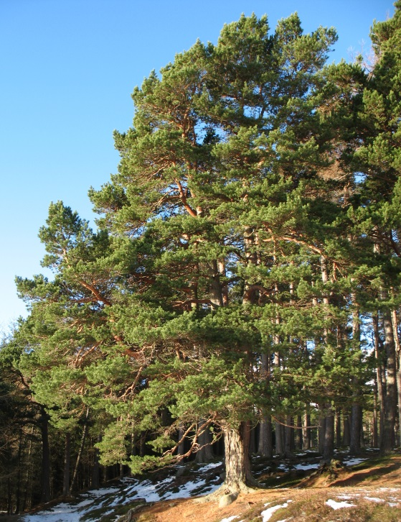**Scots pine** (*Pinus sylvestris* L.) is the most common tree in the region.

